|  |  |  |
| --- | --- | --- |
|  |  |  |

[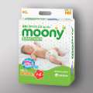](http://www.kz.all.biz/podguzniki-moony-nb90-sht-new-do-5-kg-g134166)